Project Design Phase-I
Solution Architecture

Date | 1 November 2026
Team ID | Not provided — enter the official assigned Team ID before submission
Project Name | F1 Race Intelligence: Formula 1 Performance Analytics using Tableau
Maximum Marks | 4 Marks

Solution Architecture:
Solution architecture is a complex process – with many sub-processes – that bridges the gap between business problems and technology solutions. Its goals are to:
- Find the best tech solution to solve existing business problems.
- Describe the structure, characteristics, behavior, and other aspects of the software to project stakeholders.
- Define features, development phases, and solution requirements.
- Provide specifications according to which the solution is defined, managed, and delivered.

Sample Solution Architecture Diagram:
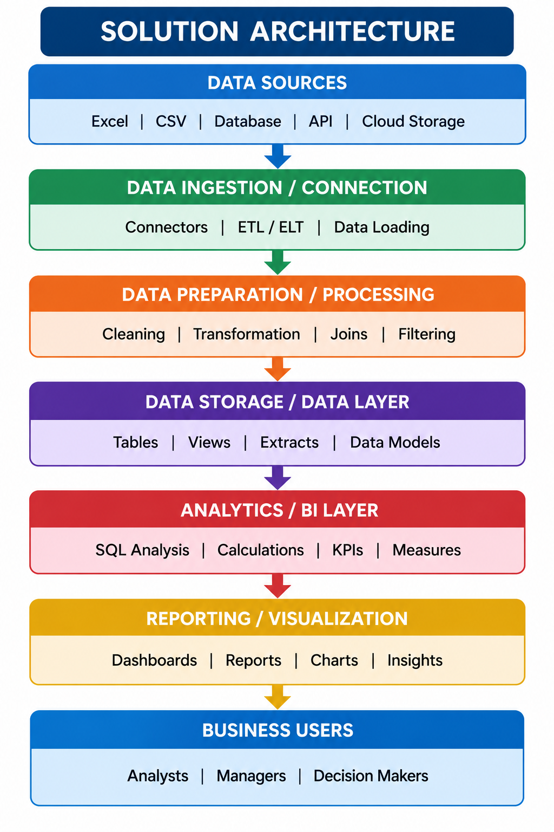

Component Description Table
Component Name | Description / Role in Architecture | Technology Used

Solution architecture overview
Layer 1 — Source: F1 Racing Project Dataset.xlsx, with circuits, championship_standings, lap_intelligence, qualifying_results and race_results sheets.
Layer 2 — Profiling and interpretation: verify schema, row counts, missing values, duplicate rows, key fields and semantic caveats. Preserve structurally meaningful nulls.
Layer 3 — Analytics authoring: Tableau workbook connects to the source data; worksheets aggregate selected measures and dimensions; dashboard/story organizes the views into a narrative.
Layer 4 — Publication: Tableau Public hosts Story1. GitHub Pages hosts the static website that links users to the Tableau story. GitHub stores website source, workbook/dataset if committed, templates and documentation.
Layer 5 — Users: performance strategist, broadcast analyst, reliability analyst, project evaluator. They consume the published views and report; no write-back or user account workflow is in current scope.

Component description table
Component | Responsibility | Current implementation / status
Excel source | Holds structured source data | Supplied workbook; five sheets; 13,748 rows excluding headers
Data QA | Counts, nulls, duplicates and plausibility checks | Offline profile documented; dataset provenance requires confirmation
Tableau workbook | Visual analytics and story sequence | Published Story1 link supplied by user; exact chart inventory must be checked in workbook
GitHub Pages | Project landing page | Live URL supplied by user
GitHub repository | Versioned website and documentation | Repository URL supplied by user
Snowflake | Optional warehouse layer | Not verified as provisioned or executed; proposed SQL only

Architecture flow
Excel workbook → data profiling / field validation → Tableau worksheets → Tableau dashboard/story → Tableau Public URL → GitHub Pages website and README → users/evaluator.
Future extension (not current implementation): workbook/CSV → scheduled ETL → Snowflake RAW/STAGING/CURATED layers → quality checks → Tableau data source → refreshed dashboards.

